Scutoid
# Source: AI Source: Provided by: [Data Path: Persons Table -> ID Column: 1, Name_En Column: Motasem Essam] -> From: [ChatGPT] on [7/25/2026]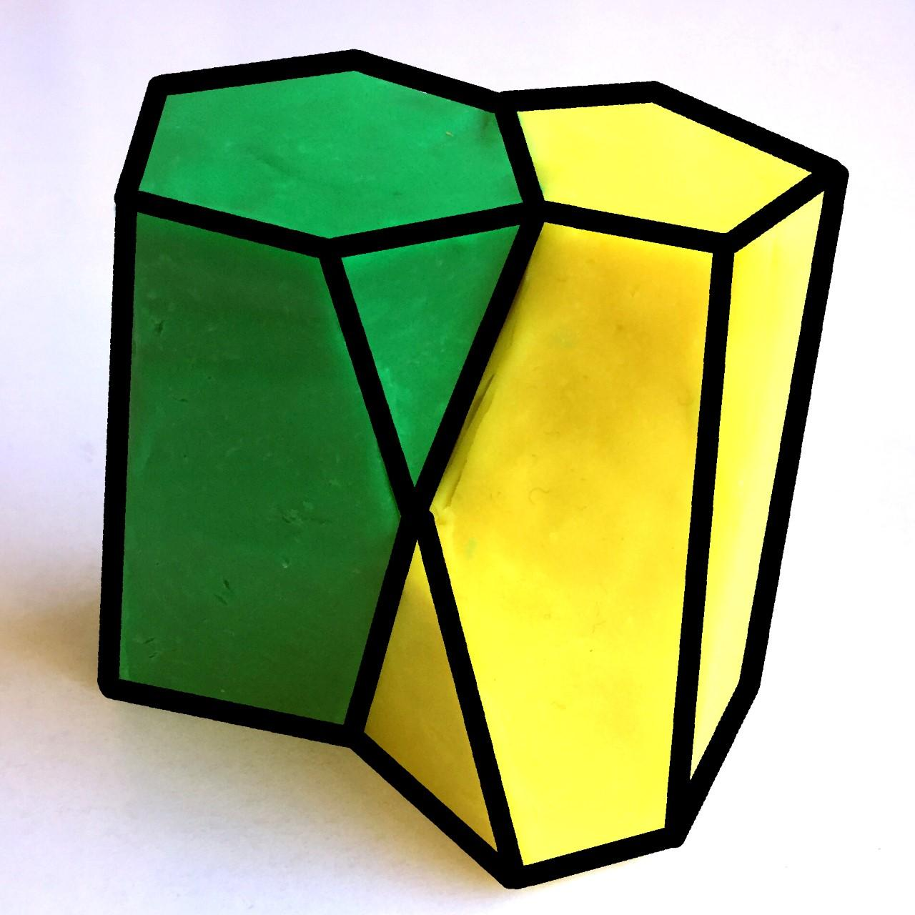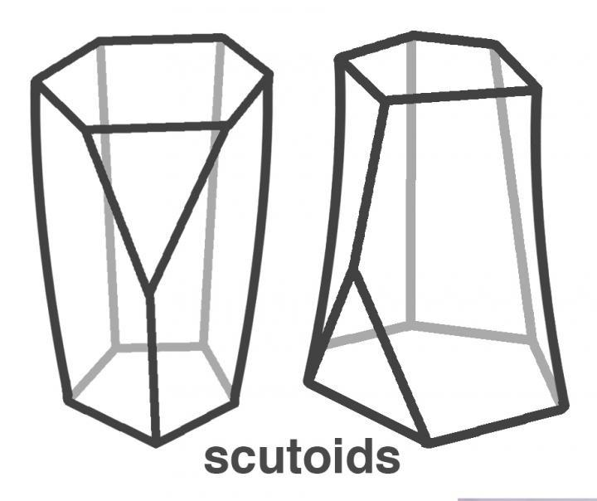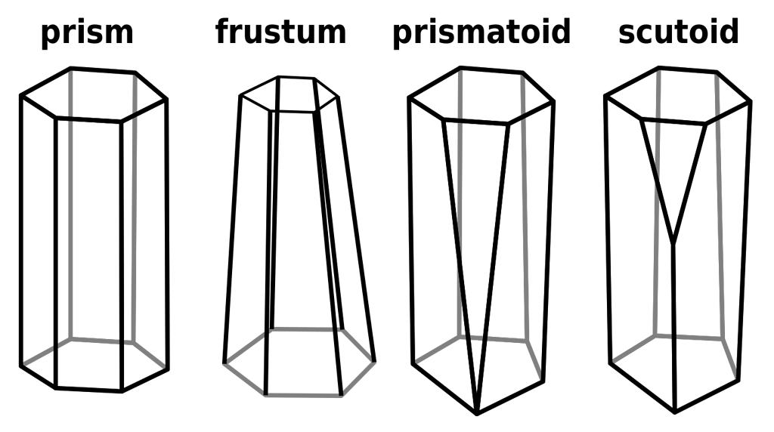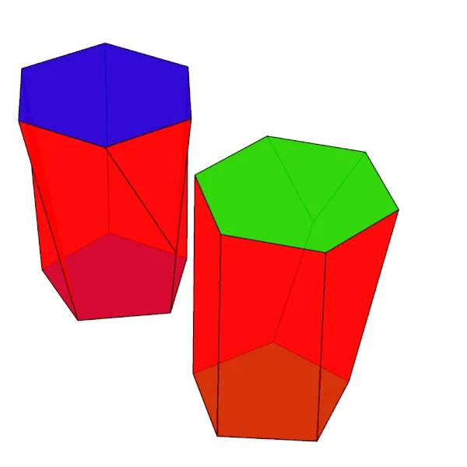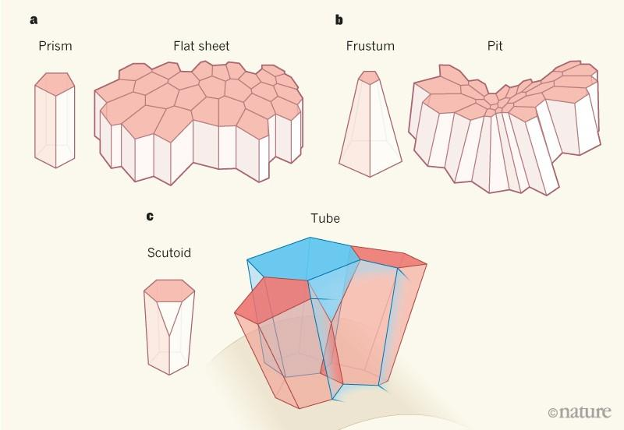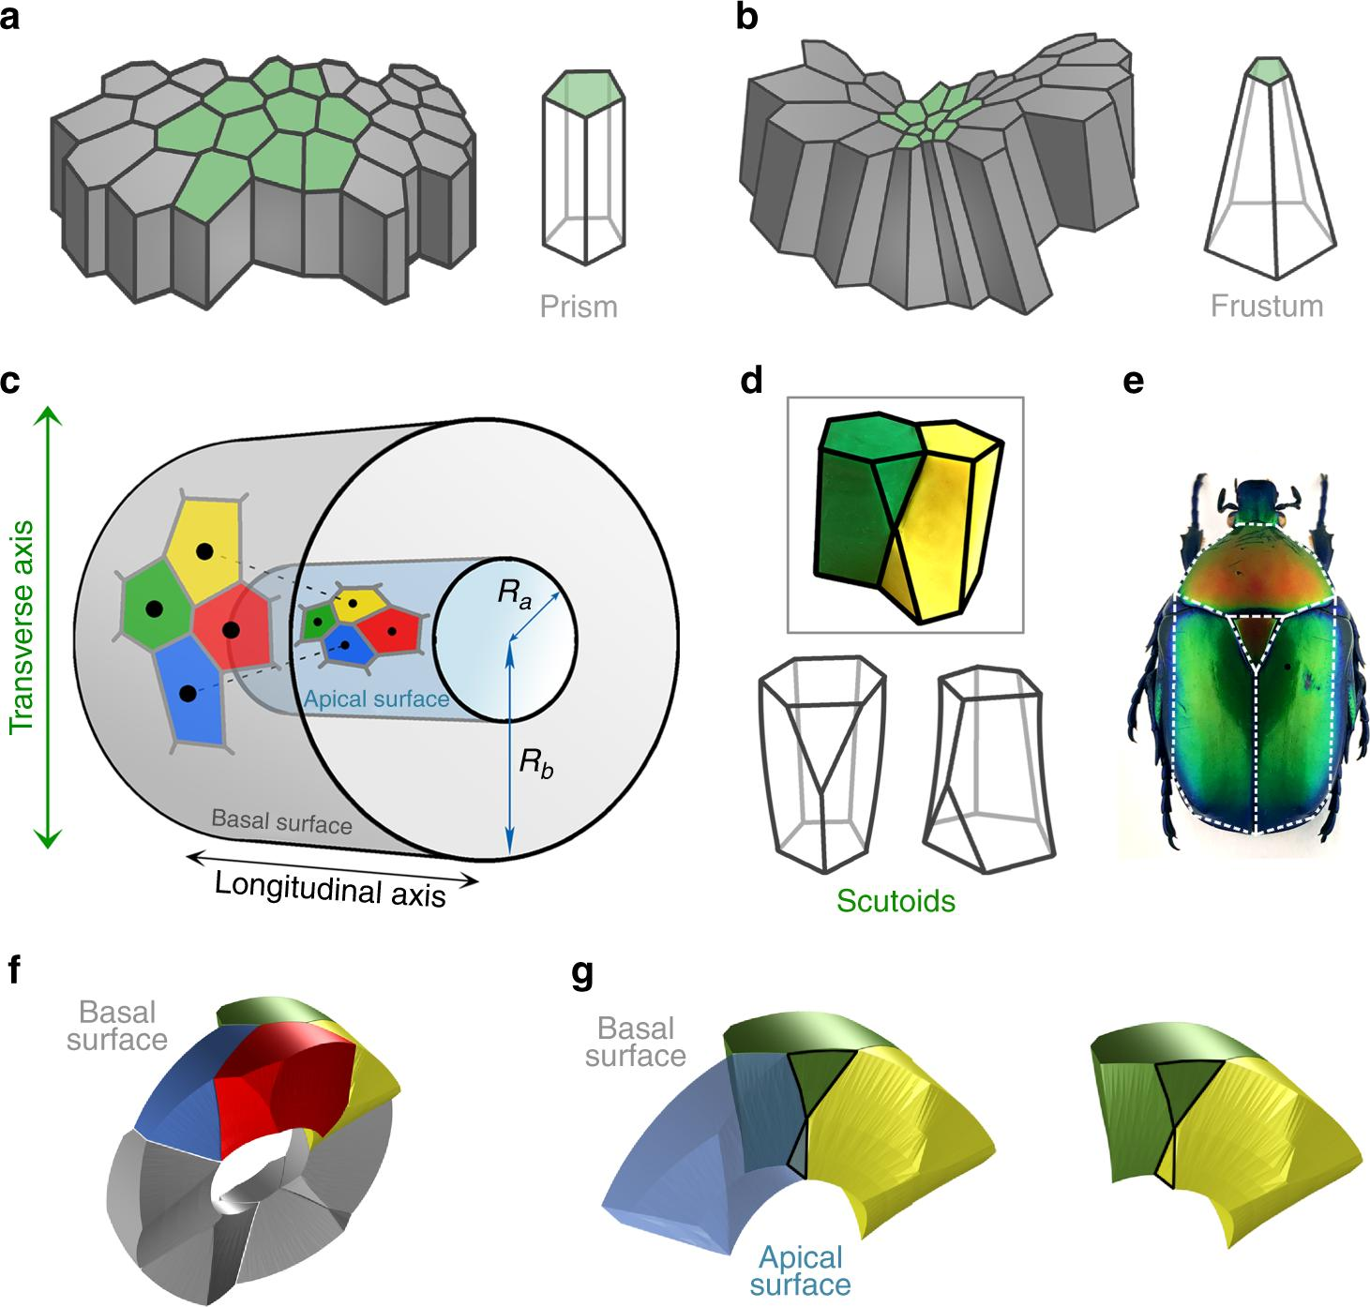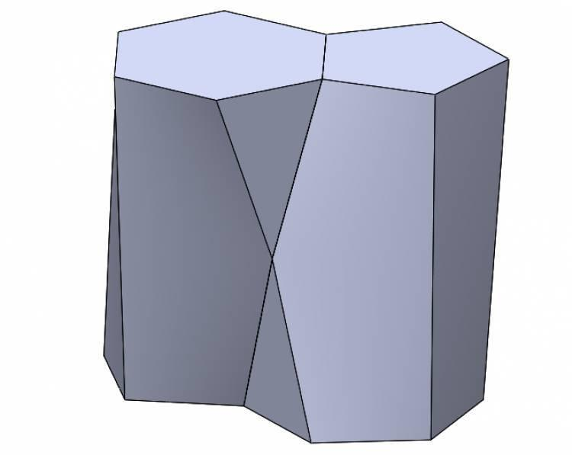

Definition
# Source: AI Source: Provided by: [Data Path: Persons Table -> ID Column: 1, Name_En Column: Motasem Essam] -> From: [ChatGPT] on [7/25/2026]
A Scutoid is a three-dimensional geometric solid characterized by two parallel or approximately parallel polygonal end faces that are connected by a series of side faces, with at least one side face typically containing a vertex that does not lie on the corresponding vertices of the opposite end face.
This shape was introduced in 2018 to describe the geometry of epithelial cells that become tightly packed in curved tissues.
Unlike a conventional prism, a scutoid can have a staggered arrangement of vertices between its two ends, producing a distinctive bent or twisted appearance.

Geometric Structure
# Source: AI Source: Provided by: [Data Path: Persons Table -> ID Column: 1, Name_En Column: Motasem Essam] -> From: [ChatGPT] on [7/25/2026]
A scutoid has the following general features:
- Upper Base: A polygonal top face.
- Lower Base: A polygonal bottom face.
- Intermediate Vertices: At least one vertex occurs along the direction between the two bases.
- Lateral Surfaces: May be concave, convex, or non-planar.
- Cross-Sections: Parallel sections between the upper and lower surfaces can have polygonal outlines.

Main Geometric Characteristics
# Source: AI Source: Provided by: [Data Path: Persons Table -> ID Column: 1, Name_En Column: Motasem Essam] -> From: [ChatGPT] on [7/25/2026]
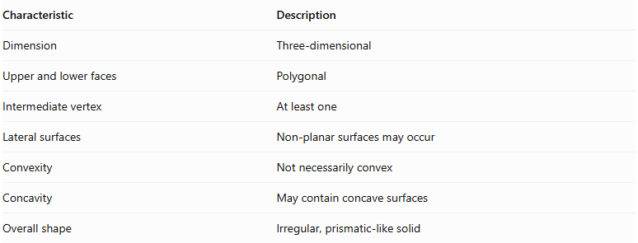
Characteristic | Description
Dimension | Three-dimensional
Upper and lower faces | Polygonal
Intermediate vertex | At least one
Lateral surfaces | Non-planar surfaces may occur
Convexity | Not necessarily convex
Concavity | May contain concave surfaces
Overall shape | Irregular, prismatic-like solid

Mathematical and Topological Properties
# Source: AI Source: Provided by: [Data Path: Persons Table -> ID Column: 1, Name_En Column: Motasem Essam] -> From: [ChatGPT] on [7/25/2026]
Unlike prisms and ordinary frustums, a scutoid does not have one fixed number of faces, edges, or vertices.
Its properties depend on:
- The number of vertices on its upper and lower bases.
- The number and positions of intermediate vertices.
- The arrangement of its lateral surfaces.
- Its particular geometric construction.
For a scutoid that forms a closed, connected, genus-zero polyhedral boundary, Euler's formula applies:
$$V-E+F=2$$
However, scutoids may have curved or non-planar surfaces, so their exact face and edge counts depend on how their boundaries are defined.

Difference Between Scutoid, Prism, and Frustum
# Source: AI Source: Provided by: [Data Path: Persons Table -> ID Column: 1, Name_En Column: Motasem Essam] -> From: [ChatGPT] on [7/25/2026]
Prism
Corresponding vertices of the two bases are connected without an intermediate staggered vertex.
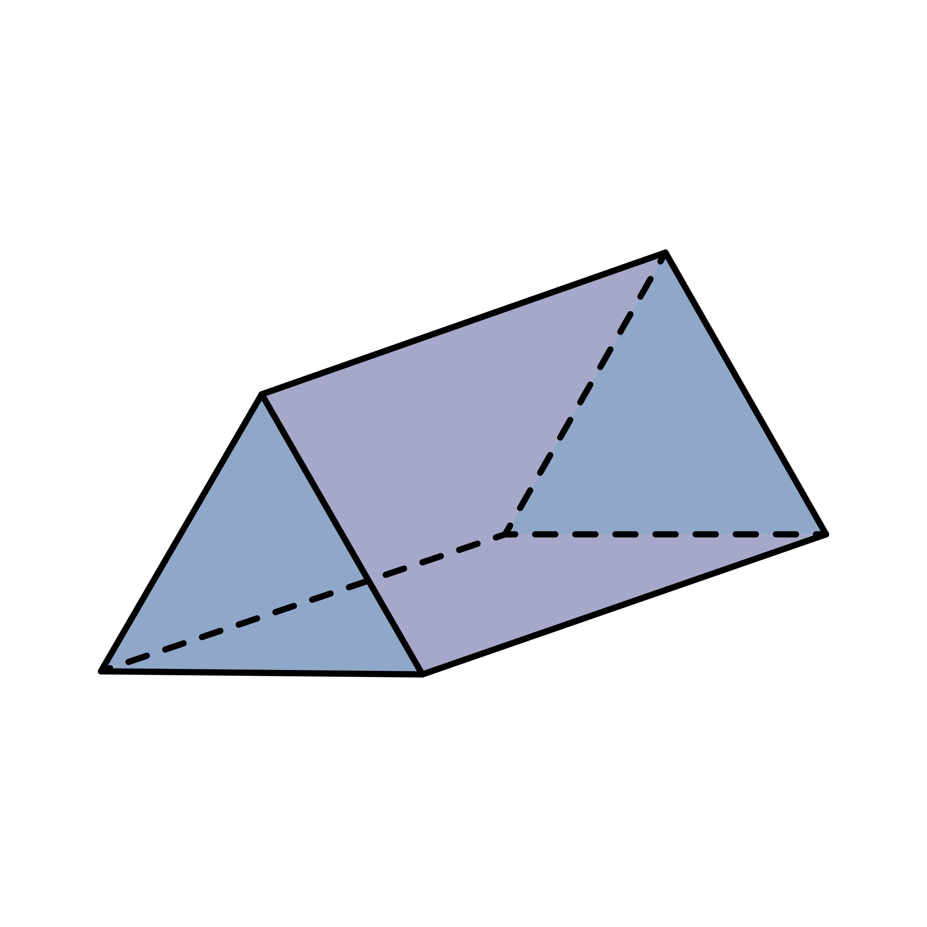
Frustum
Two parallel polygonal bases with corresponding vertices and different sizes.
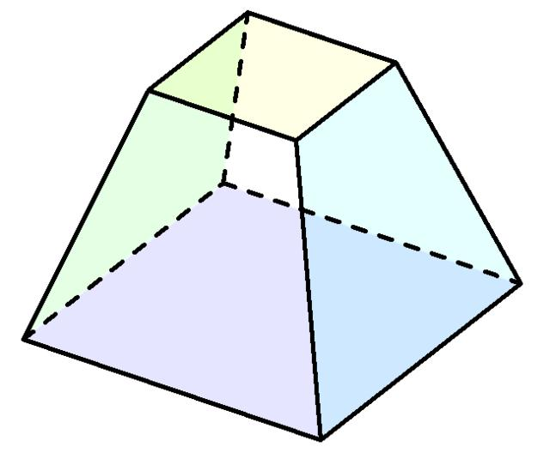
Scutoid
Has at least one intermediate vertex along its top-to-bottom direction and may have curved, non-planar lateral surfaces.

Biological Significance
# Source: AI Source: Provided by: [Data Path: Persons Table -> ID Column: 1, Name_En Column: Motasem Essam] -> From: [ChatGPT] on [7/25/2026]
Scutoids are particularly important in epithelial tissues, which form the linings and coverings of organs and body surfaces.
- They help explain how cells pack together in curved tissues.
- They allow cells to have different neighboring cells at their upper (apical) and lower (basal) surfaces.
- They help epithelial tissues bend into structures such as tubes and curved organs.
- Their geometry can help minimize the energy associated with tissue packing.
The term scutoid was introduced in a scientific study published in 2018. Its name comes from its resemblance to the scutum and scutellum shapes found in the thorax of certain beetles.

Constructing a Scutoid

Geometric Instruments
# Source: AI Source: Provided by: [Data Path: Persons Table -> ID Column: 1, Name_En Column: Motasem Essam] -> From: [ChatGPT] on [7/25/2026]
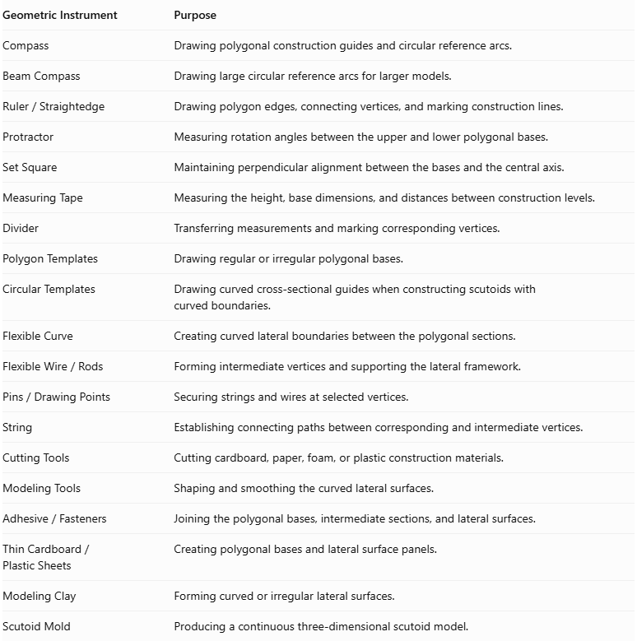
Geometric Instrument | Purpose
Compass | Drawing polygonal construction guides and circular reference arcs.
Beam Compass | Drawing large circular reference arcs for larger models.
$$Ruler/Straightedge$$ | Drawing polygon edges, connecting vertices, and marking construction lines.
Protractor | Measuring rotation angles between the upper and lower polygonal bases.
Set Square | Maintaining perpendicular alignment between the bases and the central axis.
Measuring Tape | Measuring the height, base dimensions, and distances between construction levels.
Divider | Transferring measurements and marking corresponding vertices.
Polygon Templates | Drawing regular or irregular polygonal bases.
Circular Templates | Drawing curved cross-sectional guides when constructing scutoids with curved boundaries.
Flexible Curve | Creating curved lateral boundaries between the polygonal sections.
$$FlexibleWire/Rods$$ | Forming intermediate vertices and supporting the lateral framework.
$$Pins/DrawingPoints$$ | Securing strings and wires at selected vertices.
String | Establishing connecting paths between corresponding and intermediate vertices.
Cutting Tools | Cutting cardboard, paper, foam, or plastic construction materials.
Modeling Tools | Shaping and smoothing the curved lateral surfaces.
$$Adhesive/Fasteners$$ | Joining the polygonal bases, intermediate sections, and lateral surfaces.
$$ThinCardboard/PlasticSheets$$ | Creating polygonal bases and lateral surface panels.
Modeling Clay | Forming curved or irregular lateral surfaces.
Scutoid Mold | Producing a continuous three-dimensional scutoid model.
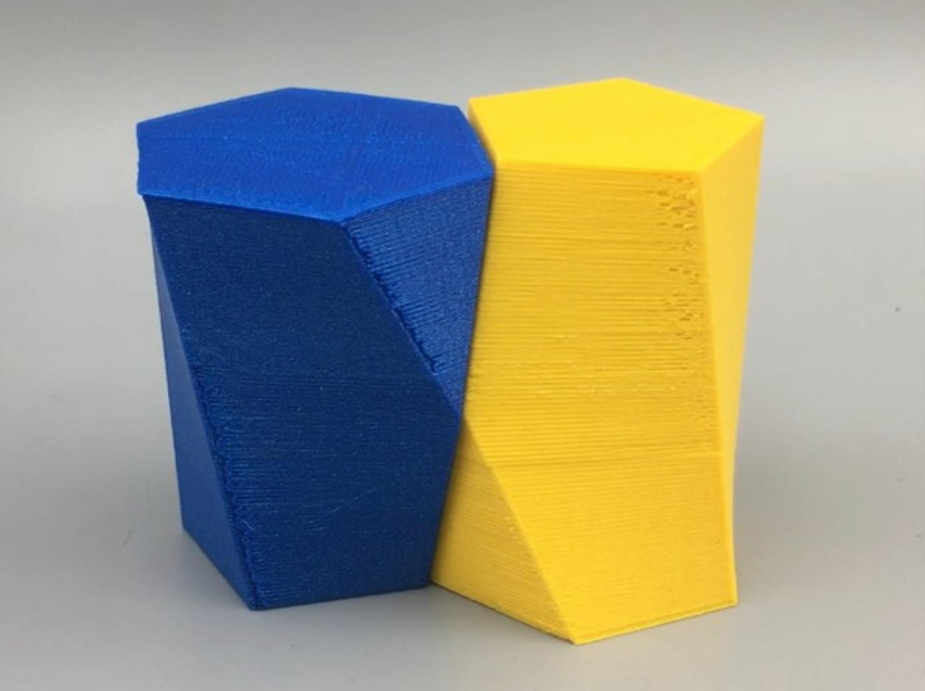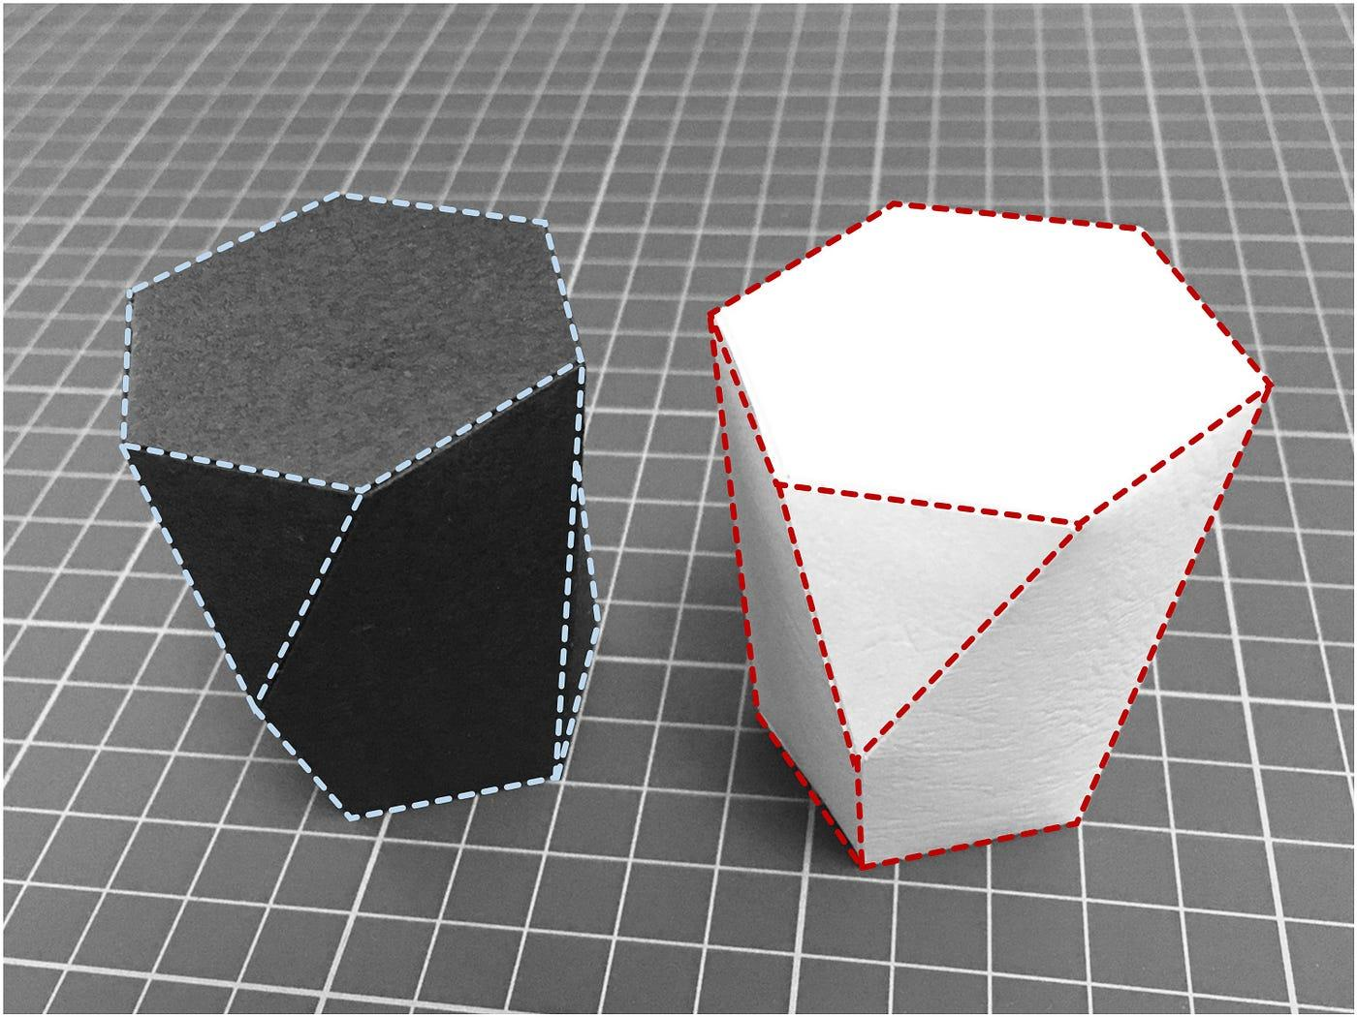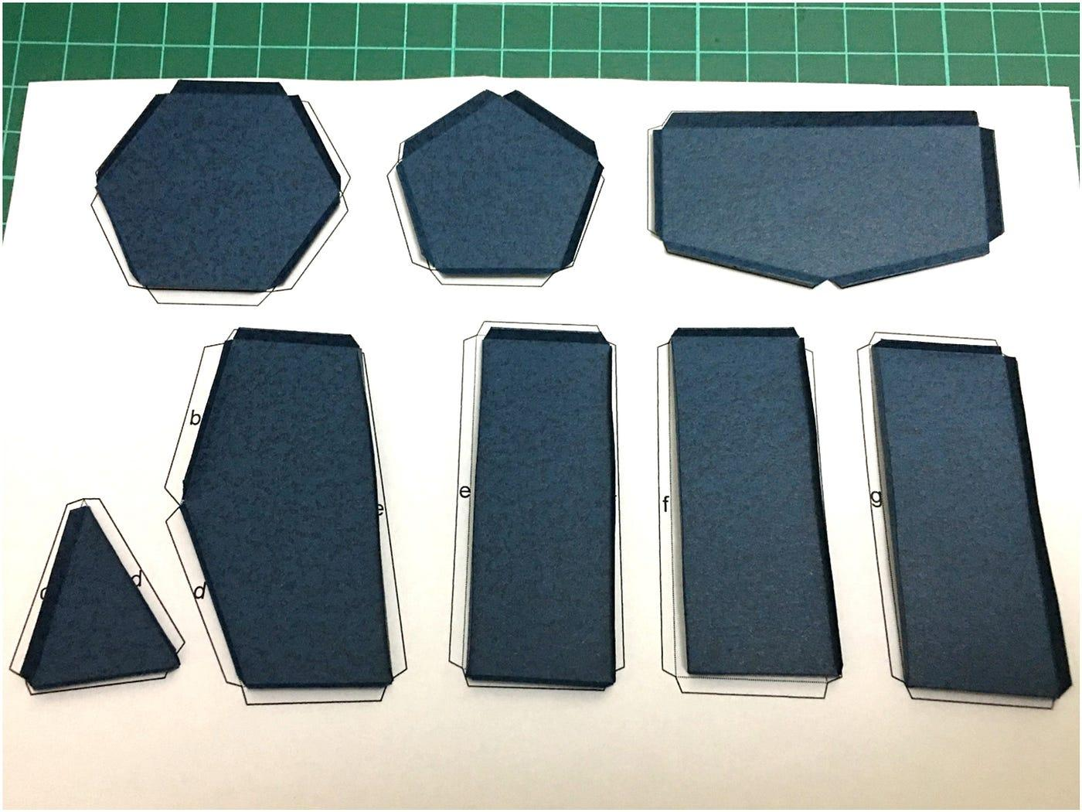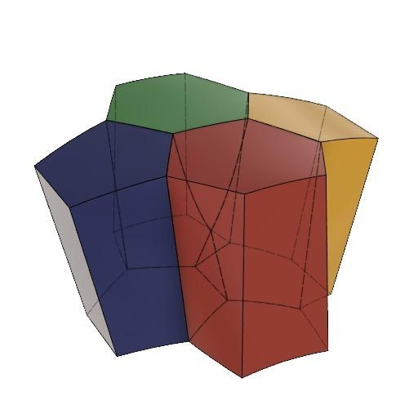

Instrument-Based Construction Procedures

Construction Using Two Different Polygonal Bases
# Source: AI Source: Provided by: [Data Path: Persons Table -> ID Column: 1, Name_En Column: Motasem Essam] -> From: [ChatGPT] on [7/25/2026]
- Select two polygonal base shapes, such as a pentagon and a hexagon.
- Draw the lower polygon using a ruler and polygon template.
- Draw the upper polygon on a separate sheet, using a different number of sides.
- Position the two polygons on parallel construction planes.
- Mark the corresponding vertices and edges on both bases.
- Determine the positions of the lateral vertices that will create the change in adjacency between the two bases.
- Mark at least one intermediate vertex between the two base planes.
- Connect the base vertices and intermediate vertex positions using strings or flexible wires.
- Construct the lateral boundaries using cardboard strips, flexible sheets, or modeling clay.
- Adjust the lateral surfaces to form the characteristic scutoid shape.
- Join and secure all components.
- Inspect the model to confirm that it has different polygonal bases and at least one vertex away from both base planes.
A scutoid is distinguished from a prism by its different base adjacency patterns and its additional intermediate vertex or vertices. Its lateral surfaces can be curved rather than entirely planar.

Construction Using an Intermediate Vertex
# Source: AI Source: Provided by: [Data Path: Persons Table -> ID Column: 1, Name_En Column: Motasem Essam] -> From: [ChatGPT] on [7/25/2026]
- Draw the lower polygonal base using a ruler and polygon template.
- Draw the upper polygonal base with a different number of sides.
- Position both bases horizontally and parallel to each other.
- Mark the center of the vertical distance between the two bases.
- Select a suitable point at the intermediate level.
- Mark this point as an additional lateral vertex.
- Connect the intermediate vertex to selected vertices on the upper and lower polygons.
- Use flexible wire or string to establish the connecting framework.
- Add further intermediate vertices if the chosen scutoid design requires them.
- Cover the framework with thin cardboard, flexible plastic, or modeling clay.
- Shape the lateral surfaces around the intermediate vertices.
- Secure the surfaces and inspect the completed solid.
The intermediate vertex is essential to the characteristic topology of the scutoid. Its position and connections determine how the neighboring relationships change between the two bases.

Construction Using Polygonal Sections and a Middle Cross-Section
# Source: AI Source: Provided by: [Data Path: Persons Table -> ID Column: 1, Name_En Column: Motasem Essam] -> From: [ChatGPT] on [7/25/2026]
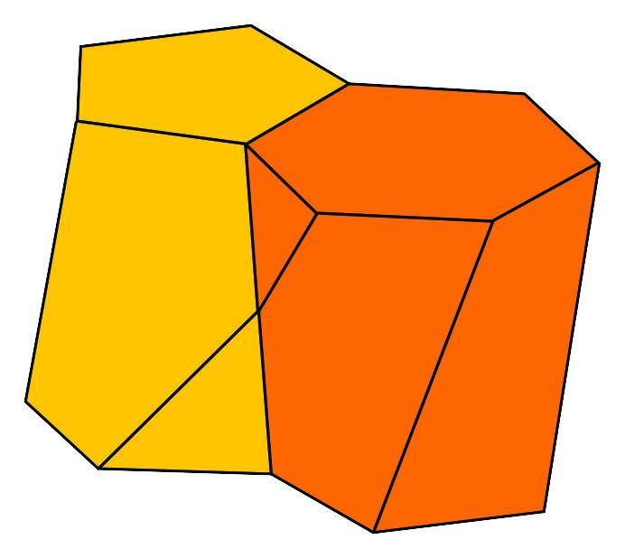
- Prepare a lower polygonal template, such as a pentagon.
- Prepare an upper polygonal template, such as another pentagon or hexagon.
- Draw an intermediate polygonal section on a separate sheet.
- Position the three sections at different heights using a ruler and measuring tape.
- Align the intermediate section according to the intended scutoid geometry.
- Rotate or reposition the upper polygon relative to the lower polygon when required by the selected design.
- Mark the vertices that will connect across successive sections.
- Connect the corresponding vertices using flexible wires or thin strips.
- Construct the lateral surfaces between the lower, middle, and upper sections.
- Shape the connections to create the additional intermediate vertices.
- Secure the sections and refine the lateral boundaries.
This is useful for constructing designed scutoid variants with a defined intermediate polygonal section. The exact intermediate section depends on the selected geometry; not every scutoid requires a square middle section.

Construction Using Curved Lateral Surfaces
# Source: AI Source: Provided by: [Data Path: Persons Table -> ID Column: 1, Name_En Column: Motasem Essam] -> From: [ChatGPT] on [7/25/2026]
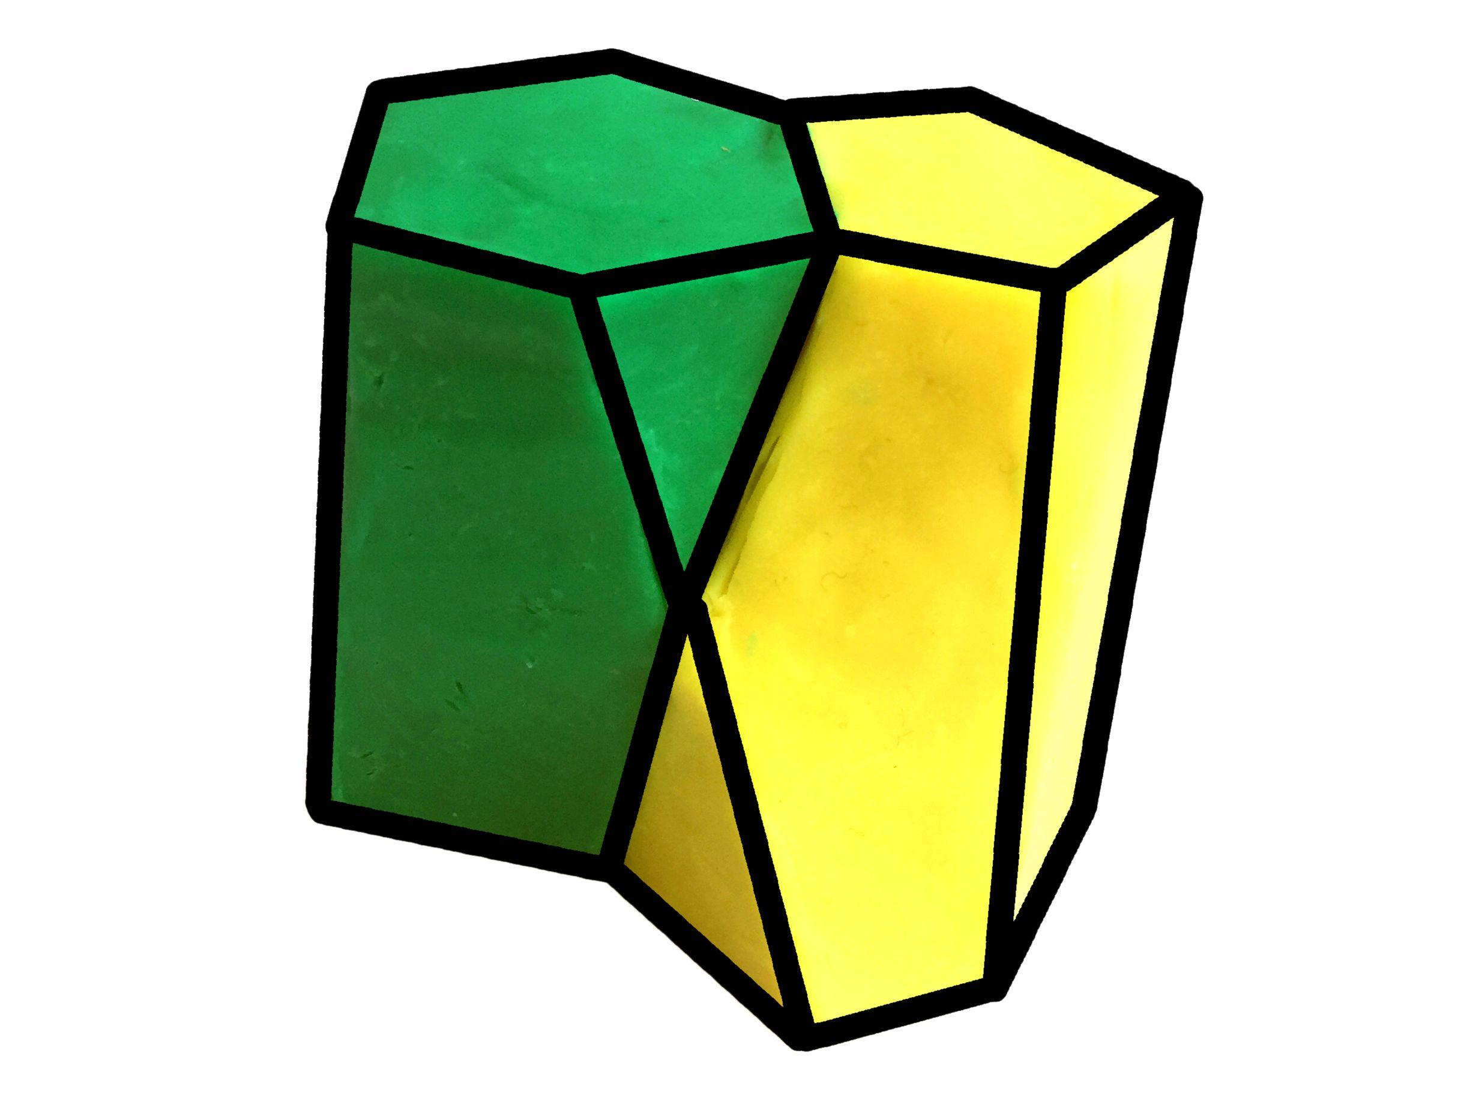
- Draw the upper and lower polygonal bases using geometric templates.
- Position the bases on parallel planes.
- Mark the intermediate vertices along the lateral region.
- Connect the base and intermediate vertices using strings or flexible wires.
- Prepare thin flexible plastic sheets or modeling clay.
- Place the material between the framework connections.
- Curve the material to create the intended concave or convex lateral boundaries.
- Shape the surfaces so that they connect smoothly to the polygonal bases.
- Secure the lateral surfaces using adhesive or fasteners.
- Smooth the connections and inspect the completed model from several directions.
Scutoid lateral surfaces may be nonplanar and can include concave regions. A model made entirely from flat polygonal panels is therefore a simplified representation rather than a faithful model of every scutoid geometry.

Construction Using a Wire-Frame Model
# Source: AI Source: Provided by: [Data Path: Persons Table -> ID Column: 1, Name_En Column: Motasem Essam] -> From: [ChatGPT] on [7/25/2026]
- Draw the lower and upper polygonal bases.
- Cut two supporting frames from thin plastic, cardboard, or lightweight wood.
- Mark the vertices around both frames.
- Position the frames parallel to each other.
- Add one or more intermediate support points between the frames.
- Cut flexible wires to the required lengths.
- Connect the base vertices and intermediate points according to the selected scutoid arrangement.
- Bend the wires to represent curved lateral boundaries where needed.
- Secure the wires using adhesive or small fasteners.
- Inspect the framework to verify that the upper and lower polygonal arrangements differ in their vertex connections.
This method is particularly useful for demonstrating the three-dimensional structure and intermediate vertices of a scutoid.

Construction Using Modeling Clay
# Source: AI Source: Provided by: [Data Path: Persons Table -> ID Column: 1, Name_En Column: Motasem Essam] -> From: [ChatGPT] on [7/25/2026]
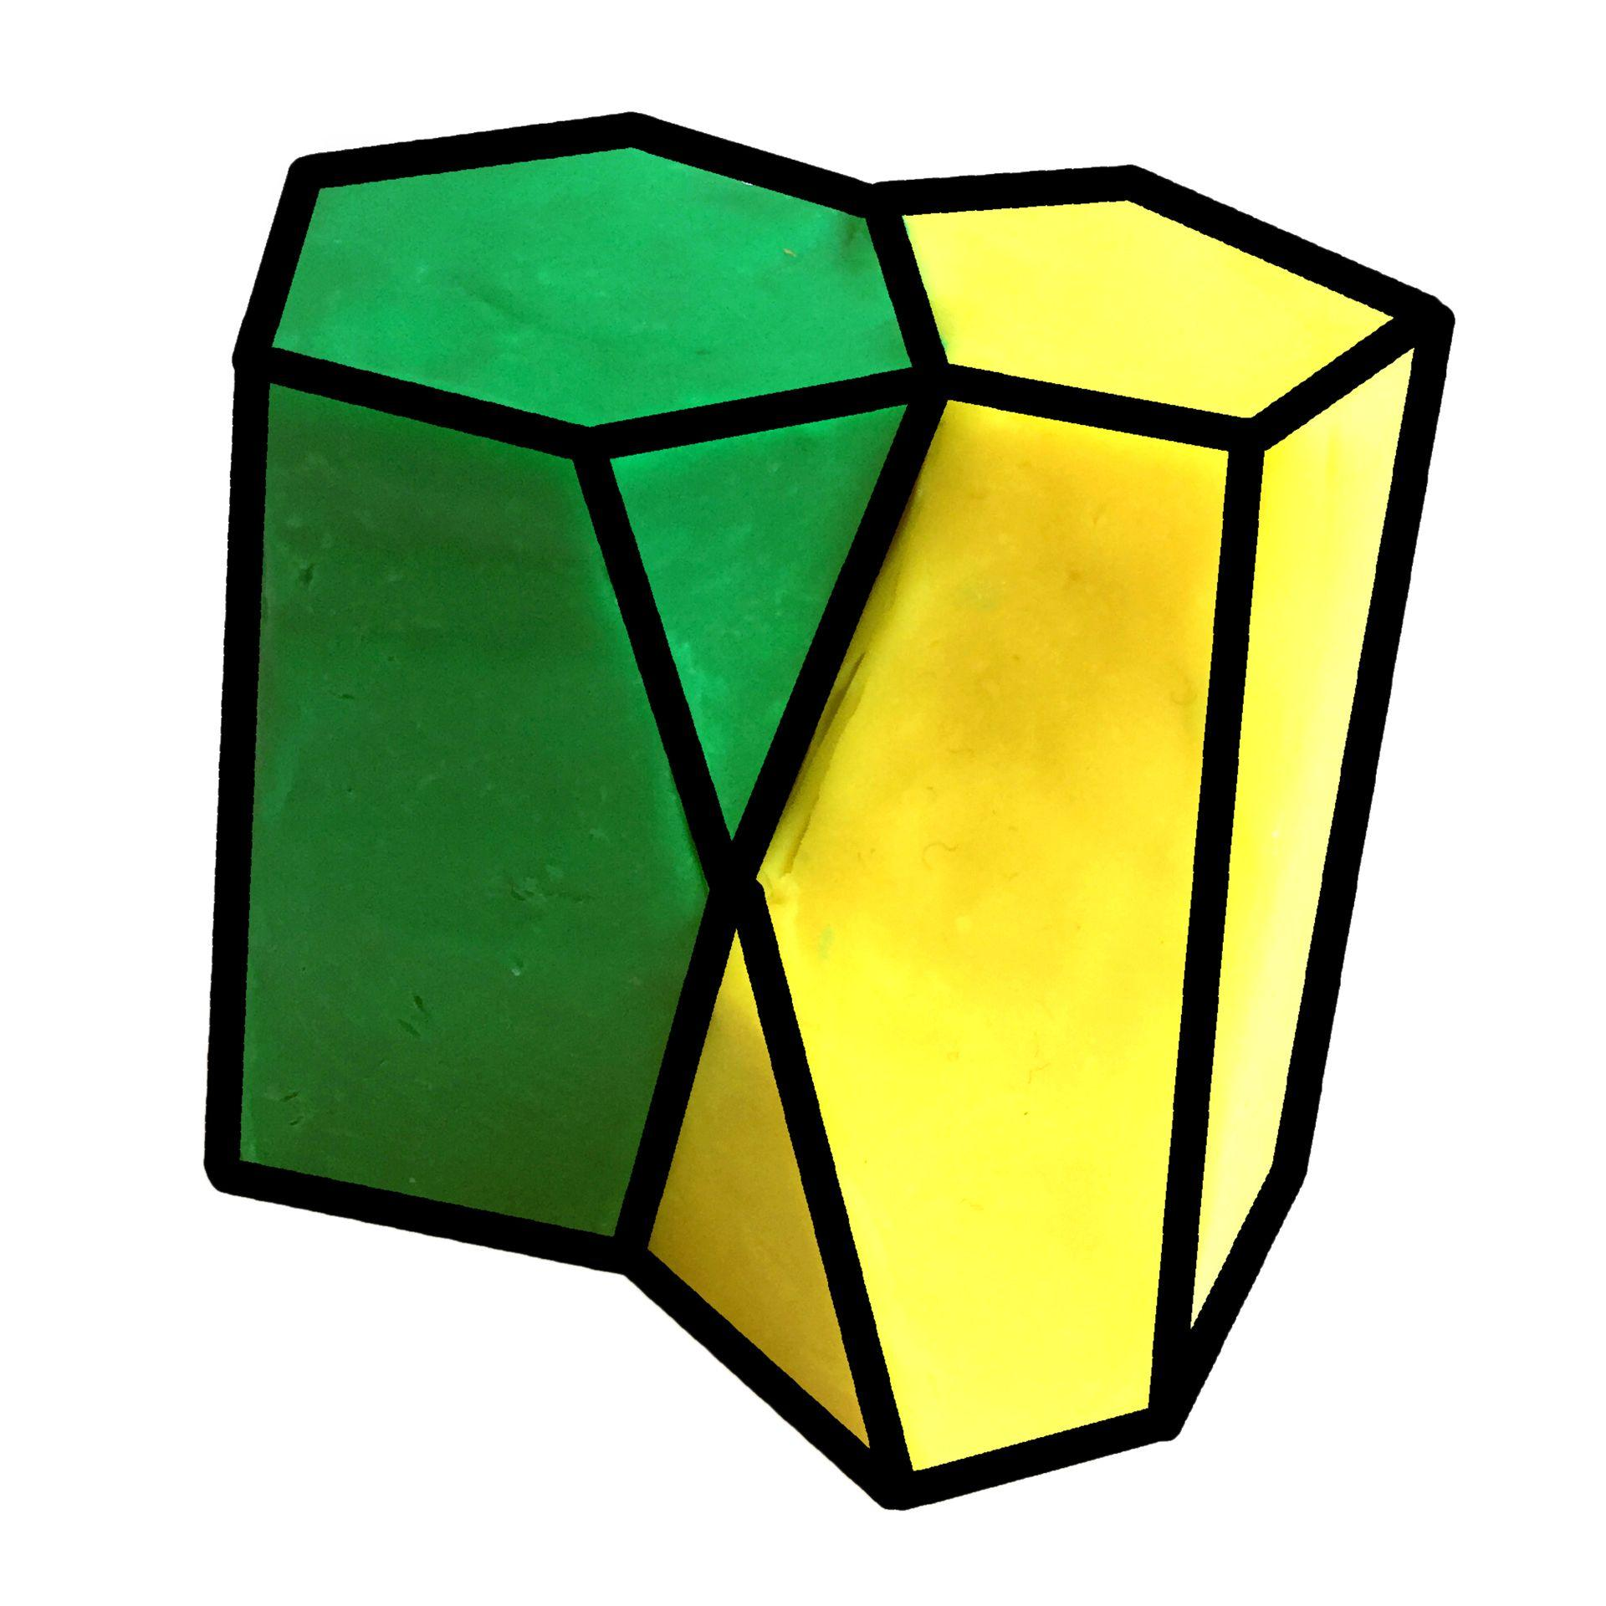
- Prepare a quantity of modeling clay.
- Draw the required lower and upper polygonal outlines on a flat working surface.
- Form the lower polygonal base from clay.
- Form the upper polygonal base with the intended number of sides.
- Position the bases parallel to each other.
- Add clay between the two bases to form the lateral body.
- Create at least one intermediate vertex away from the base planes.
- Shape the lateral surfaces around the intermediate vertex or vertices.
- Adjust the connections so that the upper and lower bases have different adjacency patterns.
- Smooth the lateral surfaces while preserving the intended concave or convex regions.
- Allow the material to stabilize and inspect the completed model.
This method is suitable for producing scutoids with curved surfaces and irregular lateral boundaries.

Construction Using a Mold
# Source: AI Source: Provided by: [Data Path: Persons Table -> ID Column: 1, Name_En Column: Motasem Essam] -> From: [ChatGPT] on [7/25/2026]
- Select the required scutoid geometry and determine its upper and lower polygonal bases.
- Draw the bases and intermediate vertices using a ruler and polygon templates.
- Construct a physical reference model using cardboard or modeling clay.
- Use the reference model to prepare a matching mold.
- Verify the mold's base shapes, intermediate vertices, and lateral surface geometry.
- Apply a suitable release material if necessary.
- Pour plaster, resin, or another suitable modeling material into the mold.
- Allow the material to set or cure.
- Remove the model carefully.
- Trim excess material and smooth the surface.
- Inspect the finished model against the reference geometry.
A mold is particularly useful when producing multiple copies of the same scutoid design.

Construction Using a Paper or Cardboard Model
# Source: AI Source: Provided by: [Data Path: Persons Table -> ID Column: 1, Name_En Column: Motasem Essam] -> From: [ChatGPT] on [7/25/2026]
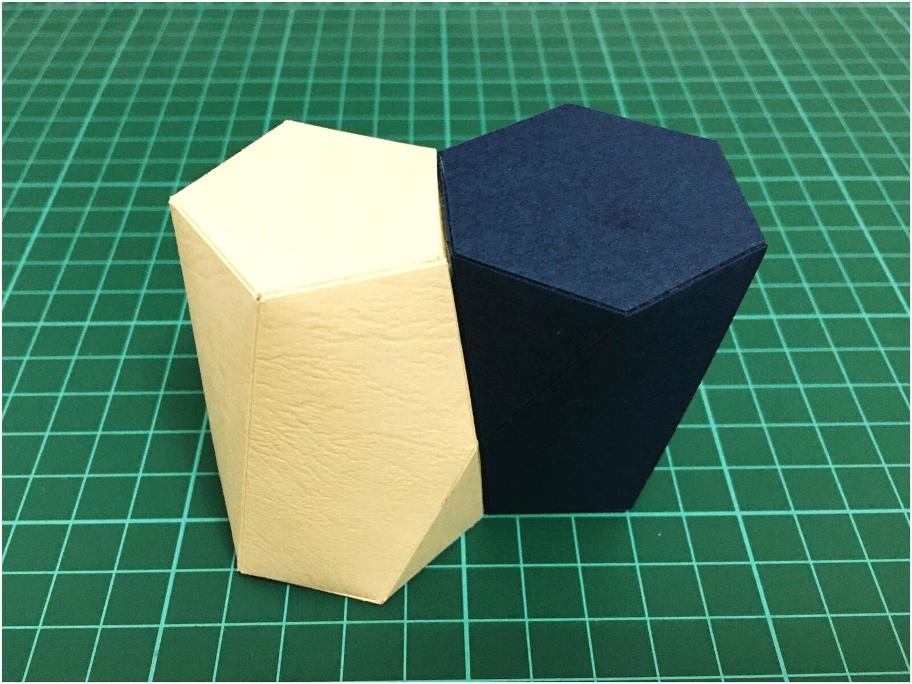
- Draw the lower polygonal base on cardboard.
- Draw the upper polygonal base with a different number of sides.
- Mark the additional intermediate vertices.
- Draw the lateral surface outlines connecting the two bases and intermediate vertices.
- Divide the lateral region into suitable construction panels.
- Add small tabs along the edges for joining.
- Cut out the bases and lateral panels.
- Fold the joining tabs carefully.
- Connect the panels using adhesive.
- Attach the upper and lower bases.
- Adjust the panels to produce the required three-dimensional shape.
- Allow the adhesive to dry and inspect the finished model.
This method produces a simplified paper representation. Curved lateral surfaces may require flexible paper or several joined panels.
Construction Note:
- A scutoid has two polygonal base regions that can have different numbers of sides.
- It has at least one additional vertex located between the two base planes.
- Its lateral surfaces may be curved, concave, or convex.
- Unlike a prism or ordinary frustum, its vertex connections and neighboring relationships can change between the two bases.
- The construction procedures above use physical geometric instruments, templates, wire frameworks, and modeling materials—not coordinate-based construction.
Reference Sources:
- Wolfram MathWorld – Scutoid
- Scutoids Are a Geometrical Solution to Three-Dimensional Packing of Epithelia – Nature Communications
- Geometrikum – Scutoid Models

Key Points
# Source: AI Source: Provided by: [Data Path: Persons Table -> ID Column: 1, Name_En Column: Motasem Essam] -> From: [ChatGPT] on [7/25/2026]
- A scutoid is an irregular three-dimensional geometric solid.
- It has polygonal upper and lower surfaces.
- It contains at least one intermediate vertex along its top-to-bottom direction.
- Its lateral surfaces may be curved, concave, or convex.
- It is not necessarily convex.
- It is useful for understanding the three-dimensional packing of epithelial cells.

Classification
# Source: AI Source: Provided by: [Data Path: Persons Table -> ID Column: 1, Name_En Column: Motasem Essam] -> From: [ChatGPT] on [7/25/2026]
Solid Geometry
└── Types of Solids
└── Scutoid

Conclusion
# Source: AI Source: Provided by: [Data Path: Persons Table -> ID Column: 1, Name_En Column: Motasem Essam] -> From: [ChatGPT] on [7/25/2026]
A Scutoid is a distinctive three-dimensional solid characterized by polygonal upper and lower surfaces, intermediate vertices, and potentially curved lateral surfaces. It is an important geometric model for understanding how biological cells arrange themselves in curved tissues.
Scientific reference: Gómez-Gálvez et al. (2018), Scutoids are a geometrical solution to three-dimensional packing of epithelia, Nature Communications.

